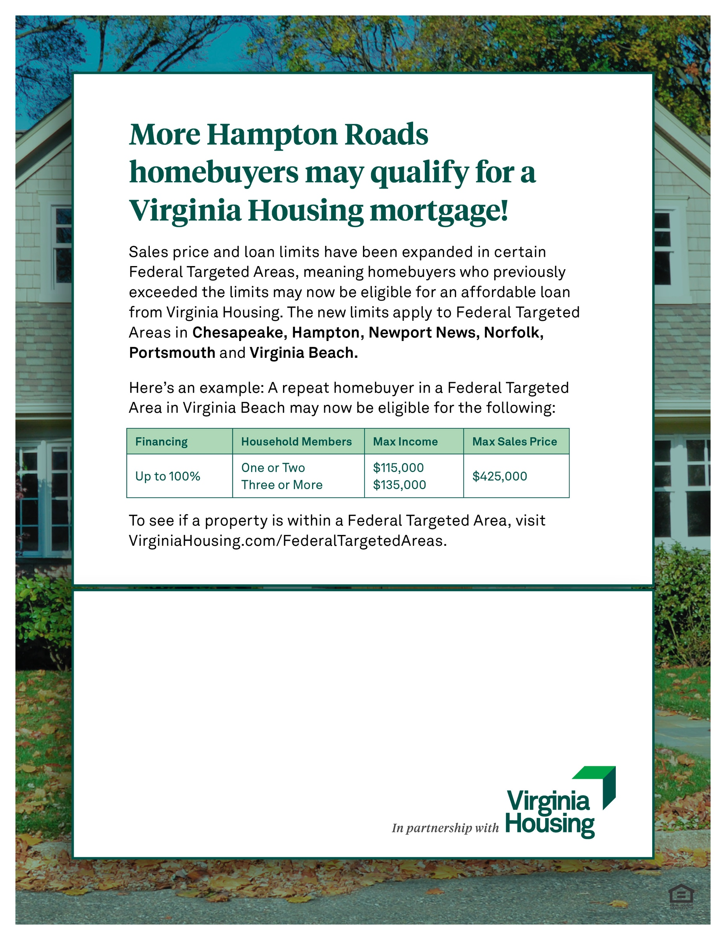

|  |  |
| --- | --- |
|  | **For more information, contact:**  Loan Officer Name, Job Title  Lender Organization Name  Office: 000-000-0000 / Mobile: 000-000-0000  Email.Address@EmailAddress.com  Address or other information |

